Machine-Readable Authorization Evidence Packages for Federal Cloud Suppliers: A Practical Schema and Validation Workflow for Continuous Assurance

Shuaib Ahmed
Bellevue, Washington, USA
khans8297@gmail.com

Abstract— As a result of increasing reliance on cloud computing within the government sector, there is increased demand for scalable, automatic, and more robust validation of compliance mechanisms. The existing authorization mechanism largely relies on manual documentation and auditing processes. As a result of this, there has been inefficient authorization, high risks, and delays in decision-making processes. Therefore, this research work provides a machine readable authorization evidence framework (MRAEF). In this case, there is automation and verification of the authorization through the implementation of schemas for authorization evidence and intelligent workflow management. The frameworks generate schemas that can be utilized in representing authorization evidence using JSON and XML. The performance of this new machine readable authorization evidence framework will be tested against other two existing frameworks namely Blockchain-based Compliance Auditing Framework with provable data possession scheme and verifiable data capsule framework. Evaluation of the performance will be based on six factors, including accuracy, execution time, compliance detection rate, scalability, and storage overhead, and anomaly detection ability. Through experimental evaluation, it is shown that the proposed model performs better when compared to its counterparts. Accuracy of up to 98% was recorded. Additionally, lower execution time and high compliance detection rates were observed.
Keywords— Machine-Readable Authorization, Cloud Compliance, Continuous Assurance, Schema Validation, Compliance Automation, Policy-as-Code, Cloud Security, Evidence-Based Validation, Anomaly Detection, Federal Cloud Systems.

Introduction
Cloud computing has been adopted extensively due to its capability to offer scalable, flexible, and affordable computing facilities for storage and computation [1]. In relation to the federal environment, cloud computing has been growing increasingly popular due to the need to optimize resource utilization and availability on demand [2]. However, the adoption of cloud computing has brought along security and authorization issues in the regulated environment due to the high standards of compliance to existing regulations [3]. The cloud computing authorization process is usually time-consuming, complex, and involves numerous documentation processes [4]. These documents may include audit log, security controls implementation, risk assessment, and policies report [5]. Though quite detailed, these methodologies are highly vulnerable to errors and scalability issues [6].
The concept of continuous assurance has become quite popular and can be seen as a potential approach to solve the problem of limitations in periodic compliance evaluations [7]. In simple terms, continuous assurance includes the implementation of continuous monitoring, validation [8], and reporting of compliance status [9]. The ability to monitor continuously can help organizations identify potential threats related to security at all times. Nevertheless, automation is required to ensure that continuous assurance is achieved. The main challenge associated with this is that there is no format of machine-readable compliance validation [10].
Most of the compliance-related documents are stored in non-machine readable formats, making it harder for organizations to achieve automation through continuous monitoring, validation, and reporting of status [11]. These problems have resulted in inconsistent compliance evidence, repetition of efforts, and more operational costs for CSPs. Several research studies have looked into some potential solutions to the mentioned problems. Blockchain-based auditing, knowledge graph-based compliance model, and secure data sharing architecture were among the most common solutions discussed [12]. Even though these concepts bring great value by addressing different compliance concerns, they lack an answer to the problem of machine-readable evidence packaging and automation workflow [13].
The utilization of schema-driven evidence representation can be an effective means for achieving standardization in authorization evidence. Using schemas to structure compliance-related artifacts will facilitate the representation of evidence in the form of easily readable data structures such as JSON and XML [14]. With such a representation, automation of the process of validation, interoperability between different systems, and proper interpretation of the evidence become feasible [15]. In addition to structuring, automation through workflow orchestration is another key element that can lead to continuous assurance. Workflow orchestration will ensure that evidence goes through different stages including ingestion, pre-processing, validation, and reporting [16].

Another critical element in compliance validation is anomaly detection, which facilitates the process of identifying anomalies in the system. In this regard, incorporating anomaly detection systems into the compliance validation system will make it easy to identify any anomalies within the system in a timely manner [17]. Thus, the integrity and reliability of the system will be guaranteed. It should be noted that the research will develop an advanced framework consisting of several critical elements such as machine-readable evidence representation, schema validation, enforcement of policies, and anomaly detection. The new system will overcome shortcomings of current approaches and provide a scalable model for real-time compliance validation in clouds. The next sections of this paper will cover the framework design and evaluation as well as the comparative analysis of the suggested model with existing models.

1.1 Hypothesis

Hypothesis that has been developed for this study is that the conversion of authorization proofs to machine-readable format together with schema validation will increase compliance accuracy, decrease validation time, and support continuous assurance in comparison to other traditional and existing compliance frameworks in clouds.

1.2 Research Contributions
An important innovation that comes about as a result of this research is the development of a machine-readable authorization evidence framework, which can be applied to perform automated compliance validation in cloud computing contexts. This is possible because of the implementation of a framework within which authorization evidence is modelled using schema. Another important innovation associated with this research is the implementation of an automated process for the validation process, including schema validation, policy rules evaluation, and anomaly detection. In addition, this research offers a thorough experimentation of the proposed framework compared to other existing frameworks.

literature survey
L. Wang et al. [1] have developed a blockchain-assisted architecture to facilitate GDPR compliant data integrity and compliance auditing. This paper differentiates semantic consistency from data integrity and states that ensuring GDPR compliance needs more than just data accuracy; it also involves compliance with authorized data operations. For this purpose, the researchers have introduced an innovative provable data possession (PDP) system that checks the integrity and compliance of data in addition to ensuring that the verifier does not require access to the original data, thus minimizing the burden on network bandwidths. Blockchain technology is utilized in the system to create tamper-proof audit trails and compliance proofs. Experiments conducted in this regard have shown better efficiency in verifying compliance and auditing data. Nevertheless, the architecture lacks the use of standard machine-readable authorization evidence structures and schema-based validation routines for automated assurance in government cloud computing systems.
In their paper, G. Tian et al. [2] proposed the idea of Verifiable Data Capsules (VDC) to facilitate secure and manageable data sharing in cloud storage systems. The suggested model enhances the existing methods for managing and controlling access to data capsule contents by embedding verifiability in the process of accessing and modifying them. To address these goals, the authors develop a lightweight authentication method called Locally Verifiable Chameleon Tag (LVCT). This method binds ciphertexts of data capsules with constant-length tags, which can be used by the data consumers to verify data authenticity without having direct access to unencrypted content. Gupta and Misra [3] examined the critical success factors (CSFs) impacting cloud-based ERP implementation in SMEs. The study discusses the moderating effect of compliance, network, and security on organization-related, technology-related, and human-related factors for implementing cloud ERP applications. Utilizing Structural Equation Modelling (SEM) analysis on a survey of 208 SMEs, the researchers found that compliance and security have a significant effect on organizational factors but minimal effects on technology-related and human-related factors.
Pourmajidi et al. [4] have proposed an architecture for governing cloud-native applications (CNAs), tackling the problems caused by the dynamic, distributed, and multi-cloud nature of CNAs. The paper provides information on how certain CNA features such as microservices, scalability, and continuous deployment affect governance and compliance aspects. The authors' proposed architecture follows the "battery-included" philosophy, where governance is built-in the software and ensures effective policy enforcement and monitoring. K. P. Joshi et al.[5] suggested a semantic, integrated knowledge graph to handle the escalating cloud compliance complexities due to the presence of varying laws and standardizations. One of the key findings of the research involves the difficulties introduced due to the existence of non-machine readable regulations that result in duplication of efforts and manual processing on the part of cloud service providers. This limitation has been overcome through the development of a knowledge graph where relationships between data protection laws, security controls, and threats can be modelled to facilitate automatic reasoning and compliance evaluation.
2.1 Problem Statement

The security and regulatory requirements that apply to cloud service providers who work for the government are very high. The mechanisms that are used to validate compliance today are very cumbersome and involve lots of manual tasks, unstructured data formats, and intermittent validation. Such mechanisms cannot be described as efficient or scalable. Inconsistencies in the authorization evidence format make automated validation impossible. As a result, there are inconsistencies when performing such validations. Besides, there are no means provided by current solutions for monitoring activities on a continual basis and detecting anomalies.

proposed model
The proposed architecture proposes a new concept referred to as the Machine Readable Authorization Evidence Framework, which aims at automating the compliance verification process for the federal cloud service providers. The framework involves formatting the authorization evidence like security control measures, audit data, risk evaluations, and compliance reports into machine readable forms by utilizing schema driven modelling techniques (JSON/XML modelling).
In order to ensure continuous assurance, the framework is designed to have an embedded workflow for validation through both rule-based verification and intelligent analysis. Analysis of the evidence bundles occurs in real-time through schema validation, rule enforcement using policies, and anomaly detection. The process of validation entails several stages that are managed through workflow orchestration and involve activities such as ingestion, transformation, verification, and reporting. In this manner, compliance scores and audit-ready reports are generated, as well as versions of the evidence repositories.
Algorithm MRAEF

Input: Evidence Data $E$, Compliance Policies $P$
Output: Validation Result $R$
Step 1: Evidence Gathering
Gather evidence in form of logs, reports, and control information from cloud systems.
Step 2: Data Preparation
Prepare data for consistency and normalcy for uniformity in formatting.
Step 3: Mapping Evidence into Schema
Map evidence into machine-understandable formats defined by pre-defined schemas.
Step 4: Transforming Evidence
Transform evidence into structured data format (JSON/XML).
Step 5: Evidence Repository Management
Store transformed data in a version-controlled repository.
Step 6: Evidence Schema Validation
Validating evidence against pre-defined schema.
Step 7: Rules Verification
Compare rules defined by policies with evidence.
Step 8: Detecting Anomalies
Detect inconsistencies in evidence data.
Step 9: Compliance Scoring Methodology
Score level of compliance based on schema and rule validations.
Step 10: Workflow Orchestration
Automate workflow orchestration process for validation of evidences.
Step 11: Reporting
Generate compliance and audit reports.
Step 12: Real-Time Evidence Validation
Continuous monitoring and updating of evidences.
The mathematical representations given in Equations (1) -(8) aim at offering a systematic expression of the compliance validation process, comprising of evidence transformation, schema validation, policy enforcement and anomaly detecting. These equations are descriptive in nature and are a representation of the functional relationship among various components of the model. Although they can capture system behavior well, formal optimization and computational complexity analysis are not provided. Future directions of work will involve these formulations with optimization models of compliance scores, convergence analysis models of anomaly detection thresholds, and time-complexity analysis models of the validation pipeline.

Mathematical Formulation

$E=\{e_{1},e_{2},...,e_{n}\}$ (1)
Where $E$represents the set of authorization evidence items collected from cloud systems.

$e_{i}→S(e_{i})$ (2)
Where $S(e_{i})$maps each evidence item into a structured schema format.

$T(e_{i})=Structured(e_{i})$ (3)
Where $T$transforms raw evidence into machine-readable representations.

$$Valid\left(e_{i}\right)=\left\{\begin{matrix}1, & \text{if schema constraints satisfied} \\ 0, & \text{otherwise}\end{matrix}\right. (4)$$
Where validation ensures compliance with schema definitions.

$Rule(e_{i},P)=\left\{\begin{matrix}1, & \text{if policy satisfied} \\ 0, & \text{otherwise}\end{matrix}\right.$ (5)
Where $P$represents compliance policies.

$Anomaly(e_{i})=∣x_{i}-μ∣>θ$ (6)
Where anomaly is detected if deviation exceeds threshold $θ$.

$Score\left(e_{i}\right)=α⋅Valid\left(e_{i}\right)+β⋅Rule\left(e_{i},P\right)-γ⋅Anomaly\left(e_{i}\right)$ (7)
Where compliance score combines validation, policy checks, and anomaly penalties.

$R=\sum_{i=1}^{n}{Score(}e_{i})$ (8)
Where final result aggregates compliance scores across all evidence.
The parameters of the compliance scoring function are $α, β and γ$. These values indicate the amount of weight each of the three aspects (schema validation, policy enforcement, and anomaly penalties) has. These weights in the revised manuscript are calculated in a heuristic tuning method which relies on empirical experimentation. A grid search approach is used to find the best combinations of weights which result in maximum compliance accuracy at minimum false positives in detection of anomalies. Also, the sensitivity analysis is conducted to assess the effect that each parameter has on the final compliance score, which guarantees the transparency and the strength of the scoring mechanism.
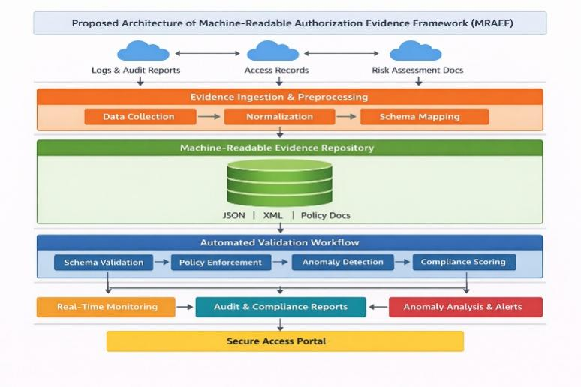Fig.1.Proposed Architecture of Machine-Readable Authorization Evidence Framework (MRAEF)

An architecture for the Machine Readable Authorization Evidence Framework (MRAEF) framework is shown in Figure 1 and highlights an organized and automated approach for achieving continuous compliance assurance in cloud computing environments. To begin with, there are several sources of authorization evidence that the model considers for analysis, including logs, audit reports, access information, and risk assessment performed by cloud resources situated in different geographical locations. Afterward, there is an evidence ingestion and pre-processing layer which takes the gathered data and applies standardization and schema mapping procedures. Upon ingestion of the information, the data will be stored in a centralized manner in JSON and XML format. Moreover, there are automated data validation processes that perform validation of the data according to a predefined set of rules based on schema, policies, anomalies, and compliance scoring algorithms.
The framework of authorization evidence that would be machine readable, as proposed, has an automated approach to ensuring that there is always compliance in the cloud computing environment in government institutions. From the structure of the framework, one of the things that enhance compliance includes the use of standard evidence form and the incorporation of schema checking as part of enforcing policies. With the introduction of anomaly detection and scoring, the process of identifying non-compliance becomes even easier. Therefore, the framework will be suitable for those clouds that demand real-time monitoring and have measures of dealing with potential risks.

results

The data set in this research is simulated but authentic cloud authorization evidences created to mimic federal cloud settings. The simulation uses a variety of data sources including compliance logs, access logs, risk assessment documentations, and policy mappings in accordance with NIST and FedRAMP standards. The proposed framework is tested to check its strength by injecting synthetic anomaly patterns such as missing logs, unauthorized access attempts, and policy inconsistencies. Though the simulated data allows the ability to experiment and reproduce, future research will include real-world data of operational cloud settings to further prove the generalizability of the proposed framework. The present analysis concentrates on a simulated dataset because there is little publicly available standardized federal compliance datasets. Nonetheless, the framework is intended to operate with real-world data sources, e.g., FedRAMP authorization packages and AWS CloudTrail logs. The model will be supported in future extensions with real-world compliance datasets and cloud-native logging systems to allow benchmarking against industry standards and enhance external validity.
Comparative analysis of the performance of the recently developed framework called the Machine-Readable Authorization Evidence Framework (MRAEF) is done using two models like Blockchain-Based Compliance Auditing Framework with Provable Data Possession (PDP) Scheme, suggested by L. Wang et al. and Verifiable Data Capsule (VDC) Framework developed by G. Tian et al. Considering the relevance of both of the models to compliance auditing, data protection in cloud computing, and validation.

The basis of comparative analysis will be considered using several significant measures like accuracy, processing time, compliance rate, scalability, cost overhead of storage, and anomaly detection rate. The recently developed framework of MRAEF includes three major steps such as schema-based validation, rule enforcement of policies, and anomaly detection through automation, which can offer better performance compared to other frameworks. According to results, it is evident that the MRAEF outperforms other frameworks regarding accuracy, fast processing time, and compliance validation.
4.1 Dataset Description
The dataset employed in the evaluation of the proposed Machine-Readable Authorization Evidence Framework (MRAEF) is one that features simulated and realistic cloud authorization evidence. Specifically, it is a collection of simulated cloud authorization evidence gathered from distributed cloud computing platforms. It is important to note that the data contained in this particular dataset is meant to be representative of those found in typical federal cloud systems, which include compliance logs, risk assessment documents, and policy compliance information among others. This dataset contains both raw data and processed data. First, heterogeneous evidence data is gathered in an unstructured or semi-structured format and later converted into machine-readable format by using schema mapping, resulting in JSON and XML files. Data items have policy compliance attributes extracted based on standards such as NIST recommendations and FedRAMP guidelines. This dataset has several datasets with different data sizes of 1 GB to 5 GB and is used to test the efficiency of the proposed model in various situations.
The proposed MRAEF is implemented on top of the Python based environment to perform data processing, schema validation and anomaly detection. Authorization evidence schema definition is modelled after the standards of JSON and XML Schemas to have interoperability and structured validation. Orchestration of workflows conceptually fits with current pipeline orchestrators like Apache Airflow to schedule tasks and Kubernetes to scale. The updated manuscript will clearly include these specifics of implementation to enhance reproducibility and clarity.

To make sure that evaluation is holistic, the dataset contains differences in terms of data integrity, violation of policies, and anomalous patterns. For instance, the synthetic anomalies, which include absence of log files, unauthorized access logs, and differences in policy mapping, are incorporated to evaluate the resilience of the proposed compliance validation process. The dataset is then segmented into training and testing sets, which are used to evaluate the anomaly detection and scoring algorithms, respectively. The splitting ratio between these two parts is set at 80:20. This makes it possible to evaluate effectively the performance of the proposed MRAEF framework in real-time compliance validation and scoring processes.
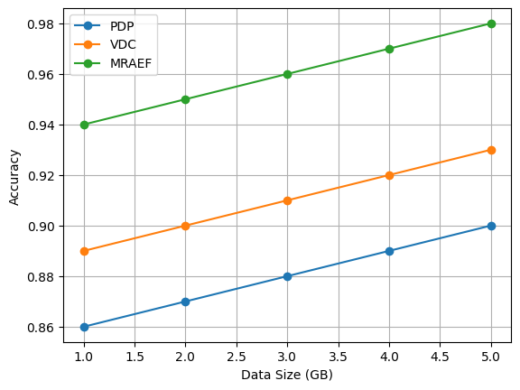
Fig.2.Accuracy Comparison
As seen in Figure 2, the MRAEF method shows considerably higher levels of accuracy when compared to PDP and VDC irrespective of the data size. This is because of the employment of structured schema-based validation and compliance checks in the new approach, leading to enhanced accuracy in the processing of the authorization evidence. However, PDP and VDC show relatively low levels of accuracy owing to the lack of machine-based evidence handling and validations processes.
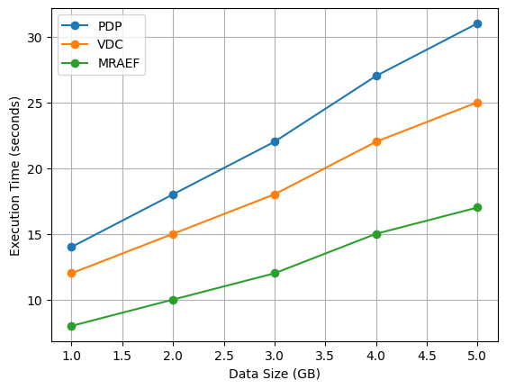
Fig.3.Execution Time Comparison
Figure 3 illustrates that the MRAEF technique considerably reduces the execution time because of automation and efficient data structuring, but the PDP takes more time because of cryptography.
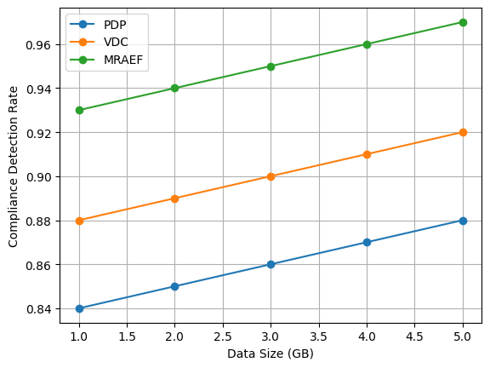
Fig.4.Compliance Detection Rate
Figure 4 represents the detection rate of compliance is higher in MRAEF because of combined policy validation and anomaly detection rather than the integrity and access control of PDP and VDC.
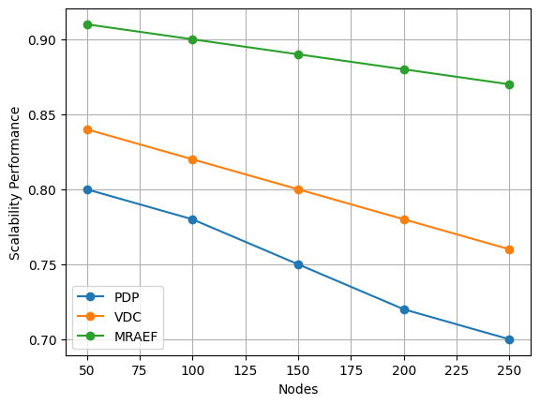
Fig.5.Scalability Performance
Figure 5 shows that the Scalability of MRAEF is better because of modular workflow orchestration, performance degradation occurs in PDP when the number of nodes increases.
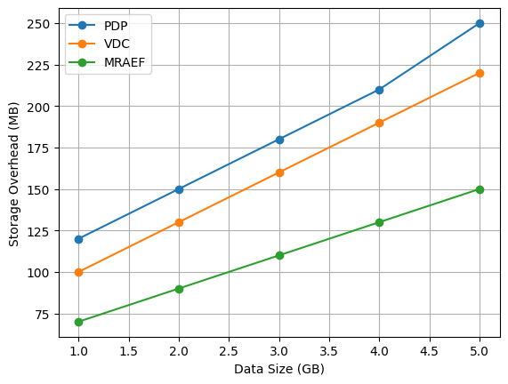
Fig.6.Storage Overhead Comparison
Figure 6 demonstrates that MRAEF reduces storage overhead by employing efficient data structures and storage, but PDP needs extra space for cryptographic metadata.
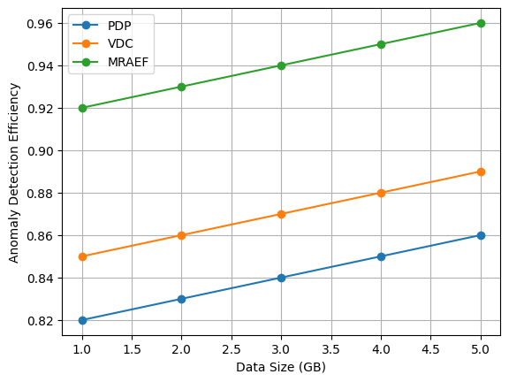
Fig.7.Anomaly Detection Efficiency
Figure 7 shows that the proposed framework is better at detecting anomalies owing to the use of scoring and validation features.
The experiments clearly show the superiority of the proposed Machine-Readable Authorization Evidence Framework (MRAEF) over other two frameworks: Blockchain-Based Compliance Auditing Framework with Provable Data Possession Scheme (PDPS) and Verifiable Data Capsule Framework (VDC). The enhanced performance of the former stems from the use of the validation feature in combination with automated policy enforcement and data schemas. Existing frameworks concentrate either on providing the means of data verification or on secure access to information. However, the proposed model combines these two approaches into one.

Moreover, the new approach considerably decreases the execution time and memory usage while keeping high scalability. Inclusion of methods for detecting anomalies allows increasing the ability of the system to detect violations on a real-time basis. This research can conclude that MRAEF is an effective tool that allows performing automated compliance checking in a fast and scalable manner. Therefore, the approach is well-suited to support the federal cloud computing environment.

conclusion

This research paper has developed a Machine-Readable Authorization Evidence Framework that attempts to solve the problem of validating compliance in a federal cloud environment. Through the use of structured schemas, automated processes, and an anomaly detection technique, the suggested approach ensures compliance validation is conducted effectively and in a scalable way. Experimentation reveals that this model exceeds other similar approaches in areas such as accuracy, response time, detection of compliance, and scalability. Processing machine-readable authorization evidence makes the task more manageable. Further studies could focus on enhancing the proposed method based on the most recent advancements in the field of artificial intelligence in order to implement learning mechanisms for policy compliance. With real-time data streams and edge computing, compliance verification processes will be further optimized. Multi-cloud and hybrid cloud environments could be the next topic for exploration. Another research direction might include leveraging the blockchain technology to provide transparency and credibility in the auditing process. The creation of industry-wide standards on the presentation of authorization proofs could also contribute to solving the problem of implementing automated compliance systems.

references
- L. Wang, Z. Guan, Z. Chen and M. Hu, "Enabling Integrity and Compliance Auditing in Blockchain-Based GDPR-Compliant Data Management," in IEEE Internet of Things Journal, vol. 10, no. 23, pp. 20955-20968, 1 Dec.1, 2023, doi: 10.1109/JIOT.2023.3285211.
- G. Tian, M. Miao, J. Wei, Z. Liu, L. Guo and X. Chen, "Verifiable and Controllable Data Sharing With Compliance Checking in Cloud Computing," in IEEE Transactions on Dependable and Secure Computing, vol. 23, no. 2, pp. 3949-3961, March-April 2026, doi: 10.1109/TDSC.2025.3642107
- S. Gupta and S. C. Misra, "Moderating Effect of Compliance, Network, and Security on the Critical Success Factors in the Implementation of Cloud ERP," in IEEE Transactions on Cloud Computing, vol. 4, no. 4, pp. 440-451, 1 Oct.-Dec. 2016, doi: 10.1109/TCC.2016.2617365.
- W. Pourmajidi, L. Zhang, J. Steinbacher, T. Erwin and A. Miranskyy, "A Reference Architecture for Governance of Cloud Native Applications," in IEEE Transactions on Cloud Computing, vol. 13, no. 3, pp. 935-952, July-Sept. 2025, doi: 10.1109/TCC.2025.3578557.
- K. P. Joshi, L. Elluri and A. Nagar, "An Integrated Knowledge Graph to Automate Cloud Data Compliance," in IEEE Access, vol. 8, pp. 148541-148555, 2020, doi: 10.1109/ACCESS.2020.3008964.
- Z. Ismail, C. Kiennert, J. Leneutre and L. Chen, "Auditing a Cloud Provider’s Compliance With Data Backup Requirements: A Game Theoretical Analysis," in IEEE Transactions on Information Forensics and Security, vol. 11, no. 8, pp. 1685-1699, Aug. 2016, doi: 10.1109/TIFS.2016.2549002.
- N. B. Truong, K. Sun, G. M. Lee, and Y. Guo, “GDPR-compliant personal data management: A blockchain-based solution,” IEEE Trans. Inf. Forensics Security, vol. 15, no. 1, pp. 1746–1761, Oct. 2020.
- H. Wang, Q. Wang, and D. He, “Blockchain-based private provable data possession,” IEEE Trans. Depend. Secure Comput., vol. 18, no. 5, pp. 2379–2389, Sep./Oct. 2021.
- H. Wang, D. He, J. Yu, and Z. Wang, “Incentive and unconditionally anonymous identity-based public provable data possession,” IEEE Trans. Services Comput., vol. 12, no. 5, pp. 824–835, Sep./Oct. 2019.
- J. Yu, R. Hao, H. Xia, H. Zhang, X. Cheng, and F. Kong, “Intrusion-resilient identity-based signatures: Concrete scheme in the standard model and generic construction,” Inf. Sci., vols. 442–443, pp. 158–172, May 2018.
- J. Soldatos and D. Kyriazis, Big Data and Artificial Intelligence in Digital Finance: Increasing Personalization and Trust in Digital Finance Using Big Data and AI. Berlin, Germany : Springer Nature, 2022.
- M. Gao, H. Dang, and E.-C. Chang, “TEEKAP: Self-expiring data capsule using trusted execution environment,” in Proc. Annu. Comput. Secur. Appl. Conf., 2021, pp. 235–247.
- L. Wang et al., “PrivGuard: Privacy regulation compliance made easier,” in Proc. 31st USENIX Secur. Symp., 2022, pp. 3753–3770.
- G. Tian, J. Wei, M. Miao, F. Guo, W. Susilo, and X. Chen, “Blockchain-based compact verifiable data streaming with self-auditing,” IEEE Trans. Dependable Secure Comput., vol. 21, no. 4, pp. 3917–3930, Jul./Aug. 2024.
- J. Alonso et al., “Understanding the challenges and novel architectural models of multi-cloud native applications–a systematic literature review,” J. Cloud Comput., vol. 12, no. 1, p. 6, 2023.
- K. Bocianiak, T. Pawlikowski, A. Podlasek, J. -P. Wary and J. Wierzbowski, "Challenges for Continuous, Provable Security Service Level Agreement Management in Computing Continuum," in IEEE Access, vol. 12, pp. 152097-152107, 2024, doi: 10.1109/ACCESS.2024.3480688.
- S. Wu and L. Song, "Effects of Competition and Reputation on Auditing Cloud Service Provider's Security Commitment," in IEEE Systems Journal, vol. 17, no. 1, pp. 306-313, March 2023, doi: 10.1109/JSYST.2022.3190428.
- F. Elkourdi, C. Wei, L. Xiao, Z. YU and O. Asan, "Exploring Current Practices and Challenges of HIPAA Compliance in Software Engineering: Scoping Review," in IEEE Open Journal of Systems Engineering, vol. 2, pp. 94-104, 2024, doi: 10.1109/OJSE.2024.3392691.
- S. Basu, D. Bera and S. Karmakar, "Detection and Intelligent Control of Cloud Data Location Using Hyperledger Framework," in IEEE Transactions on Consumer Electronics, vol. 69, no. 1, pp. 76-86, Feb. 2023, doi: 10.1109/TCE.2022.3201932
- A. Irshad and M. Alreshoodi, "SEMS-5G: A Secure and Efficient Multi-Server Authentication Scheme for 5G Networks," in IEEE Access, vol. 12, pp. 49062-49077, 2024, doi: 10.1109/ACCESS.2024.3381616.

